Clackamas River Water PRoviders

MEETING MINUTES

April 2, 2025
Meeting Via Zoom

Attendance:
Wyatt Parno, South Fork Water Board
Mark Cage, South Fork Water Board
Todd Heidgerken, Clackamas River Water
Jason Branstetter, Clackamas River Water
Elaina Turpin, City of Estacada
Wade Hathhorn, Sunrise NCCWC
Brad Albert, Oak Lodge Water Services
Aaron Beatie, City of Tigard
Dave Trotter, City of Lake Oswego
Justin Poyser, City of Gladstone
Mallory Ott, City of Oregon City
Kim Swan, Clackamas River Water Providers
Christine Hollenbeck, Clackamas River Water Providers
Rob Annear, Annear Water Resources
Steven Dowker, Carollo
Shawn Corrigan, Carollo
Kathleen Mannion, Carollo
Ryan Dougherty, Summit Water Resources
Jason Melady, Summit Water Resources
Brian Stahl, Summit Water Resources
John Lewis, 3J Consulting

Agenda
Approval of Minutes
Public Comment
AWIA – Upating Risk and Resiliency and ERPs
Aquifer Recharge Due Diligence Grant
CRWP Proposed Budget for FY 2025-26
Program Updates
May Work Session
Member Roundtable

Introductions
Wyatt started off the introduction of CRWP members and other meeting participants. Wyatt told the group that Bret Bienerth had resigned as the CRWP Vice Chair but that Brad Albert from OLWS had agreed to step in. CRWP members voted unanimously to approve Brad as Vice Chair.

Approval of April CRWP Meeting Notes
Wyatt asked if there was a motion to approve the minutes the February CRWP meeting.

Todd Heidergken made a motion to approve the April minutes Aaron Beatie seconded the motion. The motion passes.

Public Comment
None

AWIA – Upating Risk and Resiliency and ERPs
Kim introduced Carollo staff who talked about updating AWIA Plans. The presentation covered the recertification requirements for water utilities under the America's Water Infrastructure Act (AWIA) of 2018. Steven from Carollo discusses the risk and resilience assessment (RRA) and emergency response plan (ERP) updates due in 2025. He emphasizes the importance of identifying system changes, reassessing threats, and updating risk calculations. Steven also highlights the need to go beyond compliance by integrating resilience into organizational culture through training and exercises. Shawn adds that utilities should aim to create usable plans that provide value beyond just meeting regulatory requirements. Both Tigard and CRW are in the Tier 2 group to send in updated plans in 2025.

Aquifer Recharge Due Diligence Grant
Kim told the group that she had been working with Summit Water Resources to draft application for a new ORBiz ASR grant. Summit explained that the program is a new grant program through Oregon Biz, related to looking at aquifer storage and recovery feasibility projects. She mentioned that the City of Tigard already has an active ASR program, and that Sunrise is embarking on some ASR work. The group discussed whether or not the CRWP should submit the application and how to proceed.

A motion was made by Todd Heidgerken and seconded by Elaina Turpin for the CRWP to pursue this grant. The motion passed unanimously.

CRWP Proposed Budget for FY 25-26
Kim told everyone that neither she or Lindsey had received any additional feedback regarding the proposed budget, so the only changes to the budget included deferring two of the proposed Source Water Protection programs/projects to next fiscal year or some future date. The Reserve Fund for future expenses is currently fine but future expenditures needed to be clarified and formalized next year.

A motion was made by Wade Hathhorn and seconded by Todd Heidgerken to approve/adopt the CRWP Budget for FY 2025-26. The motion passed unanimously.

Program Updates
Three Basin Rule RAC – Kim told the group that she had been appointed to the Rule Making Committee for the updates to the Three Basin Rule. The first of three meeting was held on March 31st and primarily provided an overview of the Rule and the rule making process.

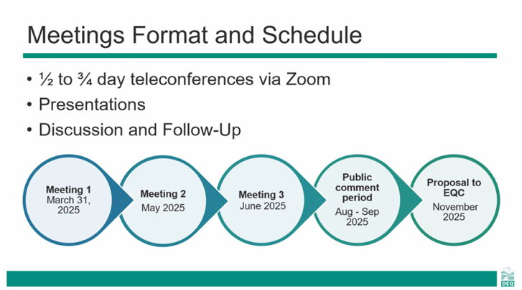

Grants – State DWSP, WES – Kim told the group that she had been working on a number of grants to fund the purchase of spill response trailers and equipment to be housed in the lower watershed. They include the OHA Drinking Water Source Projection Grant and the WES RiverHealth Stewardship Program grant.
Slow/Fast Water Booming Course - April 7th – 10th – Kim told the group that she had been working with EPA and DEQ to hold a Slow/Fast Water Booming course on the Clackamas River. The course included exercising a number of the CRWP Response Strategies. 20 people participated in the four-day training.

CRWP Member Cross Connection Staff Meeting – April 30th – Kim told the group that she and Christine had been working on efforts to CRWP member staff. This included hosting a meeting for Cross Connection staff.

Western State Source Water Protection Forum – May 13 – 15th – DEQ is sponsoring this Biannual Form that brings together state source water coordinators and partners to share and discuss challenges and solutions to source water and ground water protection challenges in the West. DEQ has asked the CRWP to host a half day watershed tour as part of this event to highlight the source water protection work we have been doing in the Clackamas Watershed as a model for other states.

Pesticide Collection Event – May 17th – The CRWP is holding a pesticide collection event on the 17th in partnership with CSWDC and ODA.

RWPC Interconnections Workshop – May 20th - Kim told the group that she was asked to be a part of this workshop by participating in panel discussion on Exercising Interconnections and will talk about the work the CRWP did around this in 2018.

Clackamas Spill Committee Annual Meeting – May 28th – Kim told the group that she will be convening the Annual Clackamas Spill Committee meeting at the end of May. This will include a GRP webtool refresher, a discussion on how to use the tool and an overview of our Regroup Notification system works.

Regional Water Providers Consortium New Youth Education Program – Christine encouraged CRWP member that are also part of the RWPC to consider adding additional funding to support the new RWPC Assembly program as the CRWP can leverage this effort locally in CRWP schools.

May Work Session
Kim told the group that the May Work Session would have to parts. The first half will be a work session will be an updated from Jacobs on the Climate Resiliency WQ project and their work to date. The second half of the work session will be a discussion on Cyanotoxins.

Next CRWP meeting is scheduled for Wednesday June, 4th 2025, from 9am – 11am via zoom

