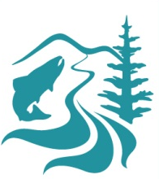

Clackamas River Basin Council
P.O. Box 1869 • Clackamas, OR 97015 • www.clackamasriver.org • Email: info@clackamasriver.org
503.303.4372 FAX 503.303.5176

Pesticide Reduction Program Deliverables: 2022-2023

Link to photos: https://drive.google.com/drive/folders/1pjG4dDc_GusVPjXSC4SEIuuXA0iW64_I?usp=sharing

- Digital Outreach:

- Include the Pesticide Pledge in local online newsletters including CRBC, city, garden club, HOA, grange, and Clackamas County Community Planning Organization → Gladstone City Newsletter has agreed to host a recurring advertisement for the pledge including a short article, images of the signs and the QR code for the pledge on our site. See the June 2023 Newsletter featuring the pledge here: https://www.ci.gladstone.or.us/sites/default/files/fileattachments/general_news/page/10079/newsletter.june_.2023.pdf A short article was also included in the Boring CPO Spring newsletter. A request to be included in newsletters for the cities of Oregon City, Estacada, Happy Valley, Canby, Sandy, and Clackamas has been made and not yet responded to.

- Share the Pesticide Pledge and Pesticide Fact Sheets through social media channels connecting and tagging identified stakeholders → Fact sheets were shared on Facebook and Instagram on 6/15/23 (https://www.facebook.com/clackamasriver.org/posts/pfbid02C14q69FDDAfEZjto1dsG6gXGoosEsNxYDUmcbU9fvH9m4xd68u5qJum9xPfd7Awxl), 6/16/23 (https://www.facebook.com/clackamasriver.org/posts/pfbid02SCwuXqKtzbAVWHEwsGneoPJirVUKvs8k8uRv4HQLSPM93SoHbcrEHhMueDNG3fAdl), 6/20/23 (https://www.facebook.com/clackamasriver.org/posts/pfbid02TJBXMMWuiYdH6GgvYHnSD5XzRRno2mfTmfrDUu7wFcbbMqqcLwskmbgKyTz6Tpf7l) and 6/21/23 (https://www.facebook.com/clackamasriver.org/posts/pfbid02Fu2PHdzRCsFqksKRM2PUEW9fqRvTtLepv6W6jrxzW51ANVPtLvqt9itjyAyZ6ir5l). A pledge post was made on Facebook and Instagram 5/17/23 (https://www.facebook.com/clackamasriver.org/posts/pfbid02Bq8PpTvctbvHxm8A85zH2PtpnqANpFYFNEnVvfETNrjRQD7qnmr5PU1vaDME4Xwol).

- Create, share, and boost Pesticide Fact sheets and Parting with Pesticides social media content with emphasis on video. Create new TikTok channel with Instagram, Facebook and Twitter integration → A TikTok channel was created (https://www.tiktok.com/@clackamasriver). A Facebook ad was purchased on May 10 2023 for $150 (https://www.facebook.com/clackamasriver.org/posts/pfbid02WeU3MuByHVuyb9thnWvKmeNEJLU3skSk6EXnna7WcNtXDshg2YBHsTEpeksoZg2hl). Please see the performance statistics in the graphic below. The purchased ad ran for 28 days from 5/10/23 to 6/7/23, it performed well and generated an estimated 53 pledges in that time. An improvement to be made in the 23-24 programming will be an addition to the pledge form asking how they found out about it. Of the 53 pledges taken through the Facebook ad campaign, 33 were residents within the watershed and received a yard sign.
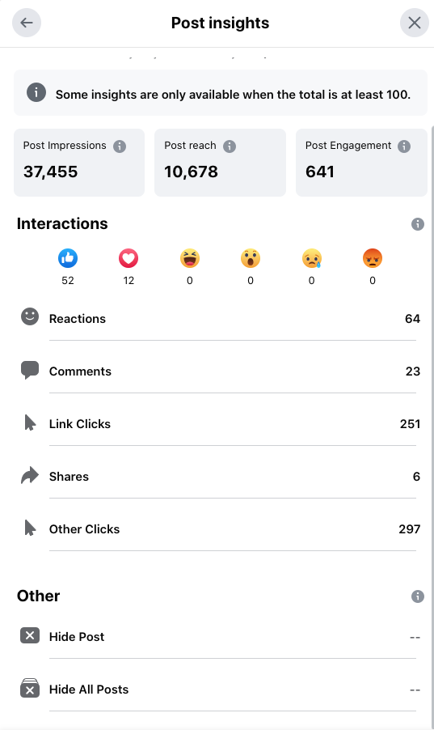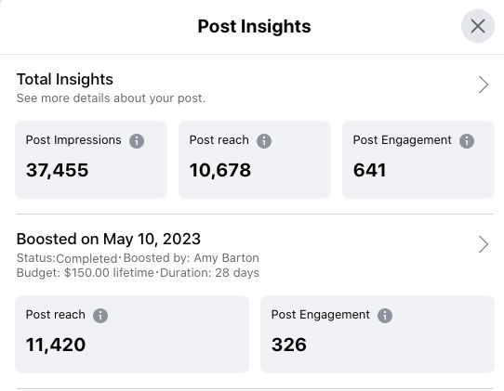

2. Community Outreach

- Pesticide Reduction outreach to community gardens, and city parks and recreation departments (Happy Valley Community Garden, North Clackamas Parks and Rec, Happy Valley Parks and Rec, Estacada Parks and Rec) → Please see attached outreach spreadsheet for exact dates for reach outs. Each named city Parks and Recreation Department was contacted but no pledges were made by a parks department this cycle. The Happy Valley Community Garden took the Pesticide Pledge and hosts a sign in a public space.

- Create and supply Pesticide Reduction displays in 5 garden centers in Damascus, Boring and Eagle Creek areas with information about the Pesticide Pledge and Pesticide Fact sheets; Create new Pesticide Pledge poster creation with QR code to Pledge page → 14 named and mapped garden center and public nursery business were approached either via email, phone or in person (see spreadsheet for contact details). 3 garden centers are currently hosting Pesticide Pledge displays and fact sheets- Phil’s Farm, Farmhouse Feed, and Boring Garden Center. Some businesses were interested but needed more time to take the request up their chain of command; no business said definitively no. New pop up posters were created for these displays, however they did not contain a QR code. To remedy this, a new flyer was created to accompany current info flyers that does contain a QR code.

- Supply Pesticide Fact sheets at local community centers and public libraries (Happy Valley Library, Estacada Library, Estacada Community Center) → Fact sheets were supplied to Happy Valley Library, Estacada Library, Gladstone Library, Sandy Library and Canby Library. Fact sheets and flyers were supplied to the Pioneer Community Center, the Estacada Community Center and the Gladstone Community Center. The pesticide pledge is included in each of CRBC’s quarterly newsletters. A presentation was given to the Boring CPO on 5/2/23 to a crowd of 50+.

In addition to the outlined community outreach deliverables from the 22-23 agreement, the Pesticide Pledge was the primary focus at the following tabling events: 4/22/23 Earth Day Ivy Pull, 5/13/23 Estacada Garden Club Plant Sale, 5/15/23 What’s Up Estacada, 6/9/23 Summer Connections, 6/23/23 Family Forest Convention, 6/24/23 Tucks Tractors & Teddy Bears, and 6/28/23 Summer Concert in The Park.

3. Workshop and Education

- Integrate Pesticide Reduction* messaging and include Pesticide Pledge enrollment opportunities in workshop programming to include 3 workshop classes targeting Clackamas River Basin rural landowners, CRBC’s riparian program participants, and urban residents. Workshops will connect local landowners with the Oregon Department of Fish & Wildlife, National Wildlife Federation, Clackamas Soil and Water Conservation District, and Backyard Habitats (Introduction to Rain Barrels and Gardens – fall/winter 2022; Gardening for Wildlife – Spring 2023; Living with Wildlife – Spring, 2023) → Pesticide Pledge information was shared at each of the following workshops: Gardening for Wildlife: Naturescaping Fundamentals on 3/4/23 with a 22 person attendance, a Virtual Rain Garden Workshop on 4/12/23 with a 26 person attendance and a follow up in person Rain Garden Workshop on 5/13/23 with a 23 person attendance.

4. Collaboration and Partnerships

- Connect with Oregon State Extension Office’s Master Gardener program to provide local master gardeners with information about the Pesticide Free and Wise Program and Pesticide Fact sheets for their educational efforts to teach pesticide reduction and safe use practices with others in the basin → Information about the program as well as flyers and fact sheets were shared with OSU Extension in Oregon City on 4/12/23, delivered to Marcia McIntyre. A follow up was made 5/23/23, Marcia gave feedback that she did not need any more materials currently and that her busy season was through August so to check back at the end of August. Marcia gave further feedback that for the MG program what would be most useful are laminated wallet sized cheat sheets of information, such as a list of common pesticides to avoid, etc.

- Work with the City of Estacada Parks Departments to update their Pesticide Wise commitment signs in their city park properties. Enlist Happy Valley Parks and Recreation and to take the Pesticide Pledge → The City of Estacada took the Pesticide Wise Pledge on 5/4/23. The installation of signs in public parks is still in progress. Also in progress is CRBC’s involvement with the Estacada Bee City Committee, through which we are able to promote the Pesticide Pledge to other public entities, individual residents and business owners. This partnership has increased our visibility in the Estacada and surrounding area.

- Work with Lower Clackamas schools to become Pesticide Pledge participants → 25 schools or school districts were sent customized emails. This outreach resulted in 4 total responses: 1 requesting literature be sent (sent 6/1/23), 1 advising to contact the district (which was done), 1 advising they were not locally owned, and 1 school took the pledge. Springwater Environmental Science School took the Pesticide Free Pledge on 4/18/23. Jenny Wetzel is the garden teacher and took fact sheets to integrate into her curriculum.

