Spatial and seasonal variations of microplastic concentrations in Oregon’s freshwater

Report prepared for Clackamas River Water Providers
October 29, 2021

Rebecca Talbot and Heejun Chang
Department of Geography, Portland State University

Overview

While there is growing concern regarding microplastic pollution in aquatic ecosystems and subsequent effects on aquatic species and human health, very little research exists regarding their presence in Oregon’s freshwater bodies. Although freshwater is believed to deliver the majority of plastics to the ocean, the biogeophysical factors driving variability in concentrations has not been fully established. We need to know where and when microplastics concentrations are high in rivers and streams to identify the sources and delivery mechanisms of microplastics.

Samples were collected from ten study sites (Figure 1), with four located in the Clackamas River watershed and six along Johnson Creek. The Clackamas sites include (from upstream to downstream): Estacada (EST), Deep Creek (DEEP), Rock Creek (ROCK) and near Oregon City (ORC). The Johnson Creek sites include (from upstream to downstream): a site near the headwaters (NHW), Regner (REG), Kelley Creek (KEL), Sycamore (SYC), Milwaukie (MIL), and Crystal Springs Creek (CSC).

In addition, a comprehensive literature review entitled “Microplastics in Freshwater: A global review of factors affecting spatial and temporal variations” was recently published with the journal Environmental Pollution, with an early access date of October 21 (https://doi.org/10.1016/j.envpol.2021.118393). This review discusses the role anthropogenic factors and physical watershed characteristics play in the spatial distributions of microplastics, as well as the role of influential temporal variables such as precipitation, runoff, and flow rate. In addition, the use of different scales of analyses in freshwater microplastic research is addressed, in which these scales may affect findings and conclusions drawn regarding potential microplastic sources or the microplastic cycle.

Objectives

While the presence of numerous pollutants and contaminants has been well-documented in rivers in the Portland area, much remains unclear regarding the degree to which microplastics impact these freshwater bodies. The current study addresses these data and knowledge gaps by investigating microplastics in two Portland watersheds with varying degrees of urban development, and by evaluating seasonal variability in microplastic concentrations with different flow regimes.

In particular, the objectives of this research are to (i) evaluate how watershed attributes such as land cover and slope influence microplastic distributions, (ii) evaluate the influence of seasonality on microplastic concentrations, (iii) evaluate the influence of flow rate on microplastic concentrations, and (iv) determine the most common forms of microplastics and evaluate links with potential sources.

Methods

Sample Collection and Processing
Samples were collected during three sampling sessions, the first of which occurred on August 28-30, 2020 and represented microplastic abundances during the dry season. The second sampling session took place at the onset of the wet season on September 24-25, 2020, with the intent of capturing the first flush event (i.e., capturing microplastics that had accumulated on land throughout the dry season and were subsequently flushed into waterways with the first rains of the season). The last sampling session occurred in the middle of the wet season on February 2-4, 2021.

In preparation for microscope analyses, a series of laboratory procedures were conducted to isolate microplastics on filter papers. Samples were first put through an organic matter digestion step using potassium hydroxide, followed by density separation using a hypersaline solution. Lastly, they were vacuum filtered onto the filter papers and stored in cardboard boxes until microscope analysis with a Leica dissecting microscope. Further details regarding sample collection and laboratory procedures are given in Appendix A.

Results and Discussion

Microplastics were found at all sites (Figure 2), with a total of 1009 microplastic particles found in the field samples. Four microplastic morphologies were observed, including fragments (n=505, 50.1%), fibers (n=173, 17.1%), films (n=71, 7%), and foams (n=23, 2.3%). Additionally, 237 tire wear particles (23.5%) were observed. Morphologies varied by site and across the sampling sessions (Figure 3). Of particular interest, analyses also showed significantly higher concentrations of tire wear particles in September than in August, indicating that these particles may be flushed into waterways at the onset of the wet season. This influx is particularly alarming, as recent research has highlighted the severe threat tire wear particles pose to salmon.
µFTIR analyses of the 105 submitted particles identified a total of nine polymer types: polyethylene (PE), polypropylene (PP), polystyrene (PS), polyethylene terephthalate (PET), cellulose, cellophane, ethylene vinyl acetate, polyvinyl acrylonitrile, and styrene butadine. Dominant polymers included PE (30%), PP (27%), cellulose (17%), and PET (9%) (Figure 4). Every particle evaluated by µFTIR was either synthetic or anthropogenically impacted in some capacity.
Differences were found between the average microplastic concentrations observed during the three sampling sessions. More specifically, average microplastic concentrations were highest in August (dry season) and lowest in February (mid-wet season). Microplastic concentrations were also negatively correlated with average flow rates in August, thus leading to the accumulation of microplastics. Dilution effects due to increased precipitation and runoff may potentially play a role in lower observed concentrations in the wet season.
Negative correlations were found between September and February microplastic concentrations and proportion of agricultural lands in the nearstream zones. This indicates that fewer microplastics are found in waterways in which the immediate upstream area is characterized by a greater degree of croplands, even during wet season periods when runoff is most likely to introduce plastic particles to freshwater bodies. Instead, microplastics may instead remain trapped in the soil.
The identification of specific polymer types can also shed light on potential sources of microplastic pollution. Polyethylene (PE) was the most commonly observed polymer (30%), which is consistent with previous findings. In particular, PE particles were composed of two sub-polymers with very different applications. Of the 105 particles assessed by µFTIR spectroscopy, low-density polyethylene (LDPE) particles were found at all but two of the study sites. These plastics are typically found in thin plastic bags, such as those used in grocery stores. In contrast, only one high-density polyethylene (HDPE) particle was reported, and was found at the Milwaukie site. As HDPE particles are commonly used in construction activities and PVC pipes, its presence at such an industrial site is unsurprising. Polypropylene (PP) was a commonly observed polymer as well (27%), and is often found in a variety of packaging materials. These particles were found at all but two of the sites, underscoring their ubiquity.

Summary and Future Research Directions

This study showed that microplastic concentrations in the Portland metro area may be influenced by certain hydroclimatic variables and subwatershed characteristics. In the dry season, lower flow rates appeared to facilitate the accumulation of microplastics, with concentrations also potentially influenced by antecedent rainfall in the mid-wet season. Additionally, microplastic concentrations may be influenced more strongly by nearstream as opposed to subwatershed factors, particularly with regard to adjacent agricultural lands. Fragments were dominant in both watersheds, likely due to the breakdown of larger pieces of plastic.

The findings of this study further our knowledge of riverine microplastic pollution in the Portland area, and contribute to our understanding of potential sources of microplastics. This information is beneficial to local officials and agencies in Portland, who are increasingly interested in knowing the potential sources and pathways of microplastics in their water bodies. Armed with such knowledge, they may be better equipped to enact policies that result in decreased concentrations of microplastics reaching aquatic environments.

As microplastic abundances often vary between the water column and benthic sediments, future research should address microplastic pollution in sediments in these water bodies to obtain a more comprehensive picture of the microplastics cycle. Additionally, future research could explore possible links between microplastics in Oregon’s freshwater and various water quality parameters.

Appendix A. Additional sample collection steps and laboratory procedures for sampling processing

Before collecting samples at the study sites, materials were prepared in the Applied Coastal Ecology (ACE) lab at Portland State University. Quart-sized glass mason jars were rinsed three times with filtered deionizied (DI) water, with a layer of aluminum foil present underneath the cap to prevent contamination from the plastic ring in the cap. Jars were then filled partway with filtered DI water, to be used for rinsing the contents of the cod end into the sample mason jar. Mason jars were also labeled with appropriate sampling information, including the month, site, and subsample number.

Samples were collected via wading at each site, and were collected from the center of the stream where possible. Sites for which this was not possible (namely sites directly along the Clackamas) required a different approach, which involved wading into the river and collecting samples at a standard depth of 1 meter. Otherwise, water depth at each sampling location was recorded using a meter stick. Where possible, stream width was also measured and recorded using a transect tape. Before beginning sample collection, the plankton net and cod end were rinsed three times in the river water to prevent cross-contamination from previous sites.

Samples were captured by submerging an 80μm mesh plankton tow net for 15-minute intervals, and three replicates were collected per site for each sampling session. While excess water flowed directly through the net, microplastic particles and bits of organic debris were captured in the cod end that was attached to the tapered end of the plankton net. Additionally, a General Oceanics flowmeter was rigged to the center of the net to capture information regarding the volume of water passing through the net, and average flow velocity over 60-second intervals was collected with a Marsh McBirney Flo-Mate 2000. For each sampling site, a control sample containing filtered DI water was opened during sample collection to capture airborne microplastics.

Organic Matter Digestion
Due to appreciable amounts of biotic material in the collected samples, organic matter digestion was a necessary first step in the process of isolating microplastics and facilitating their identification under a microscope. Samples were first filtered through a 63um sieve, with excess water draining into a waste beaker and plastics and biological material trapped on the sieve. Any large debris present on the sieve, including but not limited to leaves, pine needles, and twigs, was rinsed thoroughly with filtered DI water over the sieve and discarded. To capture any plastics stuck to the sides of the beaker, the beaker was rinsed with filtered DI water and poured over the sieve. The contents of the sieve were rinsed into a clean beaker with 270 mL of filtered DI water to standardize the volume. A glass stir bar was added to each beaker, and samples were placed on hot plates in a fume hood. Using an aluminum foil boat, 30 grams of potassium hydroxide (KOH) were transferred to each beaker. Samples were digested at 40C with the stir function set to 350 rpm for between 24-72 hours, depending upon the amount of organic material present. For each set of samples in a fume hood, a lab control containing 270mL of filtered DI water and 30 grams of KOH was used to capture microplastics resulting from contamination (e.g., microplastics present in the KOH itself, airborne microplastics).

After digestion, samples were removed from the hot plates and filtered again through the 63um sieve, and each beaker was rinsed with filtered DI water through the sieve to ensure that all materials exited the beaker. The contents of each sieve were poured into clean and prelabeled petri dishes. Using as little filtered DI water as possible, any remaining sieve contents were rinsed into each dish using a 5mL pipette. Petri dishes were then covered and stored in boxes to await density separation.

Density Separation
Due to the presence of sediments and lingering biotic material in many samples, a density separation step was taken to further isolate microplastic particles from the rest of each sample. As many of the samples had dried out in their petri dishes, they were rehydrated overnight using a thin layer of filtered DI water. A hypersaline solution was prepared in 2.5L glass jars and remade as necessary, in which 168.4 grams of sodium chloride (NaCl) was added to 2L of filtered DI water. The jar was vigorously shaken for 2 minutes, and 400mL of solution was transferred to rinsed and labeled quart-sized mason jars. Samples were rinsed out of their petri dishes into the mason jars, using as little DI water as possible. A shucking tool was used as necessary to scrape sample remnants out of the petri dishes. Jars were covered and shaken for 60 seconds, and then placed on a lab bench for 24 hours at ambient temperature to allow the contents to stratify. While the heavier sediments settled out, lighter and more buoyant plastic particles floated closer to the surface of the samples. For each session involving this procedure, a density separation lab control containing 400mL of hypersaline solution was used.

Following stratification, the hypersaline solution was vacuumed out with a filtration apparatus. In this setup, a piece of filter paper was placed on top of a glass base with sintered disc, which was mounted on a 2L Erlenmeyer flask. A glass funnel was secured to the glass base with a metal clamp, effectively pinning the filter paper between the funnel and the flask. Vacuum suction was created by connecting the apparatus to the sink with a rubber hose and turning the faucet on. Roughly two-thirds of each stratified quart sample jar was poured slowly into the funnel, with care being taken to minimize the inclusion of sediments. The suction caused the hypersaline solution to be pulled into the flask, leaving any plastic particles trapped on the filter paper. Each filter was then transferred to a clean petri dish and stored in a box to await microscope analysis.

Microscope Analysis
Stickers showing 12 numbered pie wedges were affixed to the bottom of each petri dish to aid in both orientation and the tracking of relative locations of plastic particles. Filters were examined using a Leica MZ6 dissecting microscope, and methodologies outlined in the Guide to Microplastic Identification (Marine & Environmental Research Institute, nd) were followed to aid in the distinction between microplastics and biotic material. For instance, particles showing cellular structure were excluded, along with fiber-like particles characterized by tapering. Additionally, particles that broke apart upon manipulation with a metal probe were also excluded. In these instances, the particle in question was assumed to be biological or non-plastic in nature.

Filter inspection began in the upper left section and continued in a straight line across the filter paper, with the aforementioned metal probe used to explore and prod particles to determine flexibility. Inspection of the row below commenced at the right side of the paper and continued to the left, and this horizontal pattern was repeated for each row of the filter paper. When a suspected microplastic was identified, information regarding type (fiber, fragment, film, foam), color, maximum width, maximum length, and magnification level were recorded on a datasheet. In addition, photographs were taken of each suspected microplastic and saved to a google drive for future reference and use.

Appendix B: outcomes of the project
- Presentation
Talbot, R. Chang, H. Spatial and seasonal variations in microplastic concentrations in Portland’s freshwater, Johnson Creek Science Symposium, October 19, 2021.

- Journal manuscript
Talbot, R. and Chang, H. (2022) Microplastics in Freshwater: A global review of factors affecting spatial and temporal variations, Environmental Pollution 292, Part B. 118393.

- MS thesis (defense scheduled on November 22, 2021)

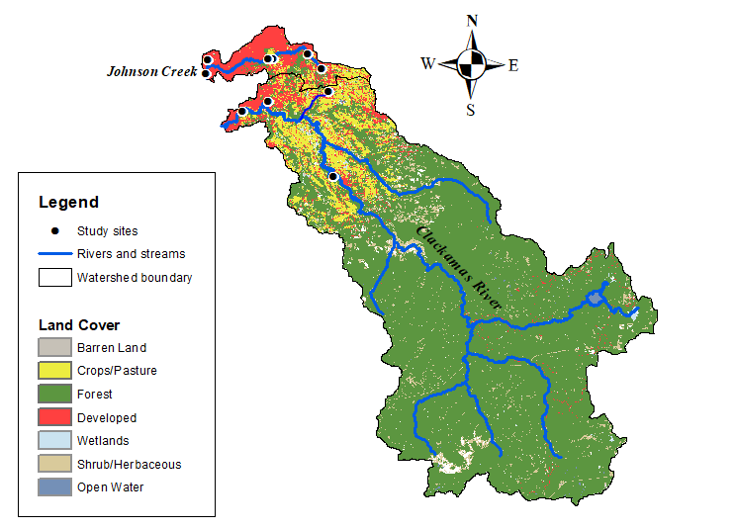

Figure 1. Map of study area land cover and sampling sites

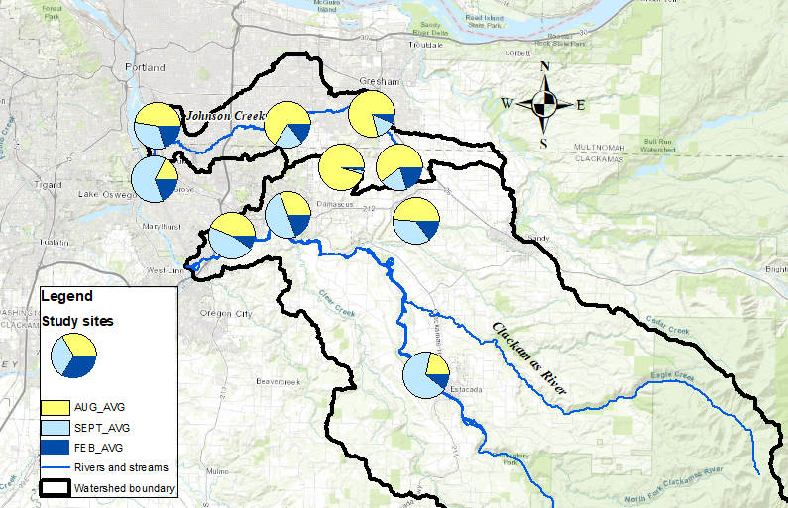

Figure 2. Map showing the spatial distributions of microplastics as a function of sampling session
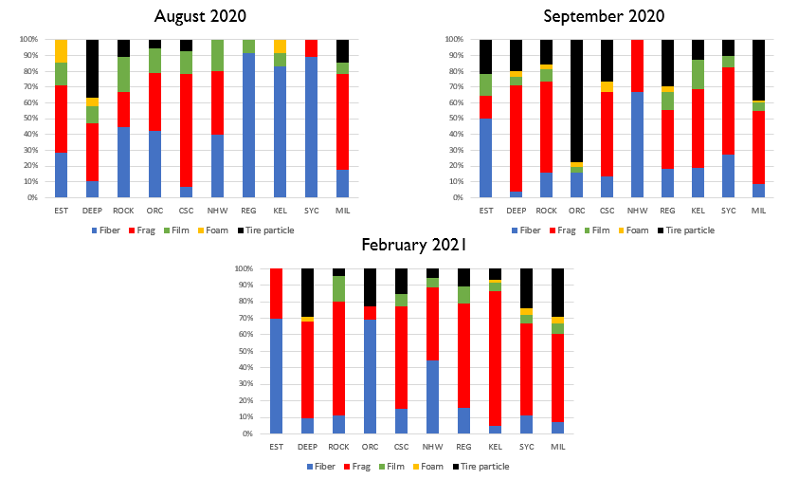

Figure 3. Proportion of microplastic morphologies observed by site and by sampling session

Figure 4. Polymer composition of microplastics evaluated by µFTIR spectroscopy

