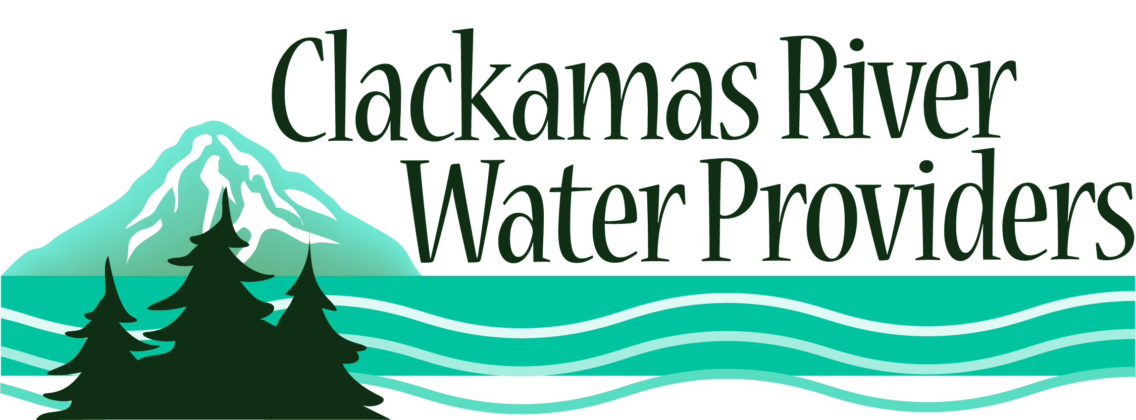
14275 S. Clackamas River Road * Oregon City, OR 97045
To schedule a presentation, check out any of the resources or for more information please contact
Christine Hollenbeck at (503)723-3511, Fax: (503) 723-3508
christine@clackamasproviders.org

Free Classroom Activities and Presentations

Water Cycle Play
Grades: 1st – 2nd
Program length: 30 –40 minutes.
Students learn about the properties of water and how the water cycle works through this role playing activity. Students become actors in their own play as they become water drops and “act out” the water cycle.

The Incredible Journey
Grades: 1st – 5th
Program length: 30- 45 minutes. With the roll of a die, students simulate the movement of water within the water cycle. Role-playing a water molecule helps students to conceptualize the water cycle as more than a predictable two-dimensional path.

From the Source to the Tap
Grades: 1st - adult
Program length: 30- 45 minutes.
Where does our water come from when we turn on the tap? How does the water get to the house? How do we keep it safe to drink? Why is conservation important? See how we teach people about conservation and learn what easy thing you can do to save water.

A Drop in the Bucket
Grades: 3rd - adult
Program length: 10 – 20 minutes
Students learn how old our water is, and just how much water is available for humans, while learning to appreciate that we need to keep our water clean through this visual demonstration.

Raven returns the WATER
Grades: 1st – 5th
Program length: 20 – 30 minutes.
A Native American myth is read about the day all the water in the world disappears and Raven goes searching for it. Students discuss how they and their families use water, how they are part of the water cycle, and ways they can conserve water so that there is enough for everyone in the future.

Water Jeopardy.
Grades: 3rd - 8th
Program length: 20 minutes.
Just like the game show, the class is broken into teams that try to see how many water questions they can answer. Overhead projector is needed.

So You Want to be a Salmon?
Grades: 3rd – 6th
Program length: 45 minutes
Role-play the life-cycle of local salmon and steelhead in order to understand the difficulties that they encounter during their migration.

*New - Enviroscape® Watershed/Nonpoint Source Model
Grades: 4th – 8th
Program length: 40 minutes
Learn how watershed pollution can come from many different sources. Nonpoint sources pollution contributes a great deal to the pollution in our water bodies. The combined affect of pollution from many small sources can have a real impact on the quality of our shared water resources.

The Tapwater Tour
Grades: 4th - 8th
Program length: 2 – 3 class sessions.
This program introduces students to scientific thought while stimulating curiosity and enthusiasm. “Hands-on” active participation in this lab leads to students discovering their drinking water for what it really is as they test it.

Taste-imony to Tap Water
Grades: 4th – 12th
Program length: 30 minutes.
Learn how to set up an experiment and then take a blind taste test to see if you can tell bottle water from tap water. Students learn more about where their drinking water comes from and the process that it goes through to get to their faucets.

Common Water
Grades: 4th – 8th
Program length: 50 minutes.
Students analyze the results of a simulation to understand that water is a shared resource and is managed. They will illustrate how multiple users can affect water quality and quantity. (This activity may involve spilled water and is best done in an outdoor activity area or an area with non-slippery floors).

The Long Haul
Grades: K - 12th
Program length: 30 minutes.
Students work together in teams to compete in a water hauling game. Students will develop an awareness of various volumes of water; appreciate today’s readily available water supplies; and relates how easy access to water can encourage people to use large amounts of water. (Outdoor activity with access to a water source

