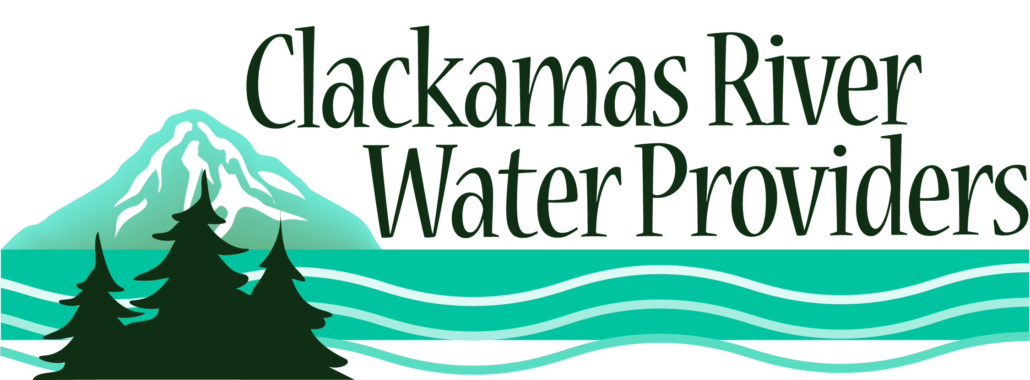
14275 S. Clackamas River Road * Oregon City, OR 97045
To schedule a presentation, check out any of the resources or for more information please contact
Christine Hollenbeck at (503)723-3511, Fax: (503) 723-3508
christine@clackamasproviders.org

VIDEO

Water: A First look
Grades: 1st – 3rd
Video Length: 17 minutes
This program illustrates the differences between salt water and fresh water; shows how living things need water to survive; describes how water can have different forms; and how water can change form through evaporation, condensation, and freezing.

*NEW All About the Water Cycle
Grades: K-4th
DVD length: 23 minutes
Even though nearly 3/4 of the world's surface is covered by water, only a very small portion of it is fresh water. So what happens when it's all used up? It won't, which is just one of the amazing facts children will learn in All About the Water Cycle. Discover the amazing process by which Earth's water supply has been recycled over millions of years.

*NEW Magic School Bus: Catches a wave
Grades: K-5th
DVD Series Length: 78 minutes
Ms. Frizzle takes her class on a rainy ride through the life cycle of a water drop, on a rough 'n' tumble journey of a boulder subject to water erosion and on a bubbly trip to the bottom of Walkerville Lake in three animated episodes of the Magic School Bus series, including Magic School Bus Wet All Over, Magic School Bus Rocks and Rolls and Magic School Bus Ups and Downs.

Water the Lost Treasure
Grades: 2nd – 5th
Video Length: 10 minutes
This video takes students to visit a museum, set sometime in the future. Dino Sorrus, the museum’s curator, explains how all the earth’s water, except for one small vial, has been wasted or polluted beyond use. Through computer graphics and animation students learn what they can do today to save the earth’s water.

Science Court Water Cycle
Grades: 3rd – 5th
Video Length: 22 minutes
Students learn about scientific concepts and sound methods through a combination of courtroom drama, animation, and humor. Through demonstration and experiments, kids will learn about the water cycle, condensation, evaporation, and states of matter.

Down the Drain
Grades: 3rd – 7th
Video Length: 30 minutes
In this video from the Children’s Television Workshop, teenage host Stephanie Yu examines the science behind water: the water cycle, the properties of water, water conservation, wastewater treatment, and water quality testing.

The Hydrologic Cycle: Water in Motion
Grades: 3rd – adult
Video Length: 20 minutes
Excellent live action video and computer graphics, gives an understanding of how water moves through the hydrologic cycle. Discover how natural events affect evaporation, condensation, precipitation, runoff, and storage. With increasing demand for usable fresh water, learn why the use and misuse of this precious resource is a global environmental concern.

What do you know about H2O?
Grades: 3rd – adult
Video Length: 20 minutes
A 10 minute pre-test is given before watching this video that answers all the questions on the quiz. Students learn just how much water everyday things use.

Professor Water and the Amazing Water Cycle
Grades: 4th – 6th
Video Length: 26 minutes
Join Professor Water and his wily sidekicks as they take viewers from Niagara Falls to the South Pole to Death Valley to the O.K. Coral. Students will pick up a world of information on the water cycle, water treatment, and water wonders. A Teacher’s Guide with real science experiments, and outcome based learning lessons can be borrowed along with the video.

Geography Basics: Climate, Water, and Living Patterns
Grades: 4th – 8th
Video Length: 24 minutes
This video explains the water cycle, El Nino and La Nina as well as the role water plays in a region’s transportation, food production, population growth, folklore, and industry.

Source of Life: Water in our Environment
Grades: 4th – 8th
Video Length: 24 minutes
This video explains where water is found and how it’s used in homes, industry, and agriculture. The fact that we cannot increase the amount of available water is explored as well as how water pollution affects humans and other forms of life.

The Oregon Story: Water
Grades: 4th - adult
Video Length: 60 minutes
This public television documentary explores both the history of water allocations around the state and how society’s demands upon it have changed over time. You’ll see examples of water-based problems and conflicts and meet some of the people who are leading the way in efficient usage and water conservation. A teacher’s guide and activities accompany the video.

Living on a Drop…a global view of water
Grades: 4th - adult
Video Length: 55 minutes
This video looks at the true cost of preserving water quality and quantity, through education and understanding. This video follows both rural and urban water users and focuses primarily on water quality issues.

Water
Grades: 4th – adult
Video Length: 60 minutes
This public television program hosted by James Earl Jones explores the major issues involving our insatiable thirst for water, and provides a global perspective on problems involving water quantity. The video is broken up into four major segments: California Water Merchants, Australian Water Wasters, Mexican Water Rationing, and New Zealand Water and Wildlife.

Water to the Last Drop
Grades: 4th – adult
Video Length: 52 minutes
This Discovery Channel video travels to Canada, the United States, Mexico and the Middle East to study the natural history of water and to investigate the latest technologies used to make the water we do have safe.

Liquid Assets
Grades: 7th – adult
DVD Length: 90 minutes
"Liquid Assets" tells the story of essential infrastructure systems: drinking water, wastewater, and stormwater. These complex and aging systems—some in the ground for more than 100 years—are critical for basic sanitation, public safety, economic development, and a host of other necessities of life. The documentary highlights communities from across the United States, providing an understanding of hidden water infrastructure assets, demonstrating watershed protection approaches, and illustrating twenty-first century solutions.

*New - Flow
Grades: 7th-adult
DVD Length: 84 minutes
“Flow” is an award-winning documentary investigation into what experts label the most important political and environmental issue of the 21st century – The World Water Crisis. A case is built against the growing privatization of the worlds dwindling fresh water supply with an unflinching focus on politics, pollution, human rights and the emergence of a domineering world water cartel.

